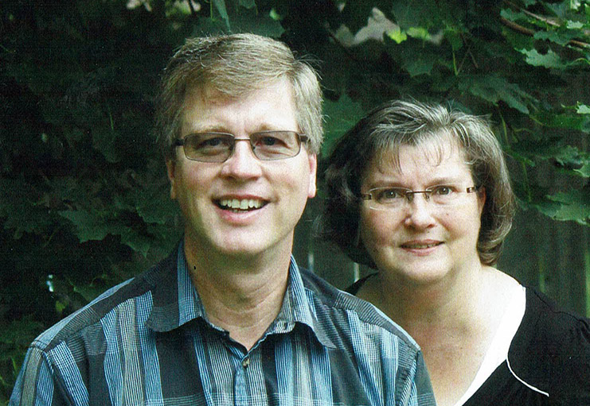

August 4, 2021

Hi, Parkwood Gardens Church family.

I just arrived back last night, via the US. It was nice to sleep in my own bed last night!
Gail and I were both thankful to have navigated all of the challenges involved in COVID-era international travel, and were grateful to have had the opportunity to engage and help with what MAF is doing in Angola.
To get into the country, we were required to complete a COVID test in Luanda, the capital, and then immediately travel in a van for 15 hours to Lubango, where MAF has a base. There we had to quarantine for 8 days, and then have another test, before being released.
After this, we were able to engage with the community.
For Gail, this meant working with a small international school operated by wives of two of our pilots. She was able to provide instruction and one-on-one tutoring for some of the students, and engage some of the techniques that she uses as a learning therapist. The students in the school come from a wide variety of backgrounds, some from the church and mission community, others from other expat families that are employed in the region.
For myself, I was able to complete the required training and flight testing for our pilots as required by the Angolan aviation regulator, and MAF standards. This involved many hours of “ground school” and various flights, some for training purposes, and others for ministry to communities.
On the way to Angola, we accompanied a new MAF couple who were starting their first term of service. Andrew and Jaelyn, with a pilot/engineer background and nursing background respectively, are a great addition to the MAF team there in Angola.
Most of the last three weeks was spent carrying out initial training and instruction on how to operated MAF’s Caravan aircraft into the interesting airstrips that we go to. We were very blessed to be able to get the required amount of training flying and supervision of some early ministry flights done in the allotted time. We flew for the last time just the day before Gail and I had to get back on the van for the 15 hour drive to the capital again.
During the last couple of weeks of our time in Angola, it became apparent that a new Cessna Caravan aircraft that we had been “keeping our eye on” was going to be available for MAFC to purchase. This aircraft was brand-new in 2019, but the African airline that had ordered it had gone bankrupt. It was equipped in a way that made it ideal for the sort of operations that we do in Angola as well. We made a very low offer to the broker and the finance company, which was accepted by them. This is a few months ahead of when we would have expected to have raised all of the funding for our aircraft replacement campaign, but we really felt that this was God’s provision for MAF Canada, and our board and several significant donors agreed with this.
So as we left Angola, Gail and I went our separate ways. I travelled to the USA, to do some initial familiarization with the new aircraft, and then deliver it to Minneapolis for some further modifications. This was completed on Friday, and I travelled back to Canada yesterday.
The masks and neckties given by church people were a great hit. Please thank everyone again for donating these.
We were able to donate neckties to all of our MAF national workers, and to the entire male graduating class of the Angolan theological institute that we partner with. There were enough left over for most of the male faculty at the school as well. Formal dress is still a big deal in Angola, and these were welcome gifts for new pastors, as they set out to commence ministry in churches all over the country.
Some masks were donated to national staff and theological students and their families, but many were delivered to the mission hospital in Lubango that we partner with. Receiving a quality, washable, reusable mask was a huge thing for many of these people, many whom are living hand-to-mouth.
We are grateful to the church family for praying for us while we were gone.
We really sensed the Lord’s provision a number of times, as we dealt with difficult travel situations, and navigated visa renewals etc.
We were grateful that we were able to get our major ministry objectives completed, and were glad to help make a bit of a difference for remote communities in Angola who are facing very difficult and uncertain times with the COVID economy, and a looming drought in some areas.
We are also very thankful and excited for how God is providing for our aircraft replacement need. He has provided much beyond what we were expecting, for about $1 million less!

Lowell

